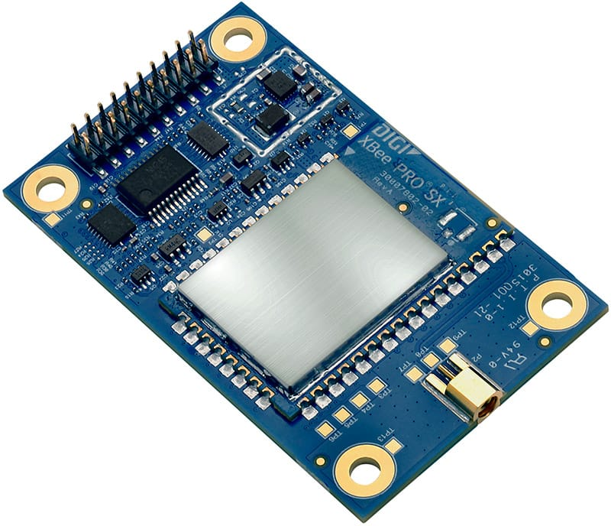

<https://www.digi.com/products/xbee-rf-solutions/sub-1-ghz-modules/xtend-module>

Xbee Python library docs

<https://xbplib.readthedocs.io/en/stable/>

XBee_A

SH = 13A200

SL = 4187AD0C

Xbee_b

SH = 13A200

SL = 4187AC85

Followed these directions and successfully configured the two modules to talk to each other!

<https://www.digi.com/resources/documentation/digidocs/90001526/tasks/t_configure_remote_xbee_modules.htm>

Used minicom on /dev/ttyUSB0 to send a message to home device at 9600 8N1 baud

“this is a test”… It worked!!

Received by home device

10/14/2018 9:04 PM

I realized that I need to use python on my desktop PC to talk to the attached Xbee module

So I installed Python3-32.

To install modules need command:

C;\Users\Rick\AppData\Local\Programs\Python\Python37-32>python –m pip install –upgrade pip

C;\Users\Rick\AppData\Local\Programs\Python\Python37-32>python –m pip install serial

Need to fix windows paths for python

10/15/2018 10:15 PM

Got the xbee to read the received sting data correctly on the PC:

counter=0

try:

ser = serial.Serial('COM3')

except serial.serialutil.SerialException:

ser.close()

ser = serial.Serial('COM3')

while 1:

ser_text = ser.readline().decode('ascii').rstrip()

outline = str(counter) + ': ' + str( ser_text )

print (outline)

# print (dump(str(ser_text)))

counter += 1

Gives:

…

481: Write counter: 481

482: Write counter: 482

483: Write counter: 483

….

The “decode” is necessary to change the binary string into a python string. The rstrip chops off the newline that is necessary on the transmit side to get the xbee to transmit a line and the receiver to read a line. No longer necessary to print out since python puts a newline on every print statement.

I am exclusively using transparent mode on both TX and RX.

I think that we will not be able to use transparent mode if we want to interleave ADC samples in the middle of the transactions. This looks like it might be a REAL pain since it seems that the XBEE API python code on the Rapsberry pi errors out every time I try it.

Perhaps we can just use the API mode on the PC end … Need to test digi-xbee API on the PC to see if it works there.